**Translating S&T Policy and Program into Grassroots: China’s Experience and Lessons**

**Prof. Zhang Liyan**

**Tianjin University of Finance and Economics, Tianjin, China**

**Email:** [**liyan_zhang_666@163.com**](mailto:liyan_zhang_666@163.com)

**Mobile(wechat)13702160683**

1\ Logic of Promoting Grassroots Innovation

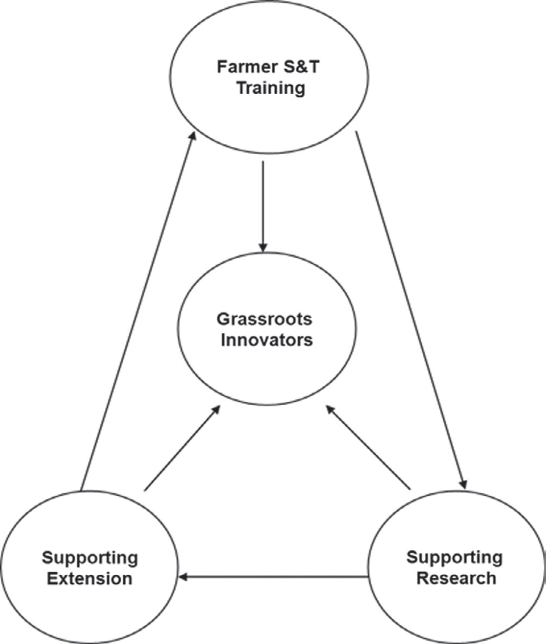

2\ Mechanism of Translating Government S&T Policy and Program into Grassroots



3\ Two Examples:

Example 1: Baodi County, Tianjin, China

**MOST**

**Tianjin S&T Committee**

**Baodi S&T Bureau**

**Baodi S&T Bureau**

**Tianjin S&T Committee**

**Companies**

**Other Research Institutes**

Association:

Summing up experiences

Institute:

Research

Cooperative:

Marketing

School：

Training,

Proving office space

Example 2: **Governance structure for GRI in Hua County**

Town-level Association for S & T

County-level Government

County-level S

& T Bureau

County-level IPR Office

County-level Association for S & T

County-level Party Committee

County-level Committee of CPPCC

4\ Summing up

◎ Central government policies and program do can be translated into grassroots innovators.

It is under the condition that grassroots innovators’ innovations contribute to the local economic development.

* Governance structure at county level for grassroots innovation promotion is quite flexible.
* At grassroots, the interactions among grassroots innovators and local government, enterprise and other stakeholders are active.